PROPERTY
SERVICES

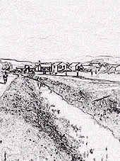
Dyke Filling Guidance

What you need to know

Under the Land Drainage Act 1991-section 23

The erection of any culvert or altering of any culvert is likely to affect the flow of a watercourse. Therefore no person shall erect any culvert or alter any culvert without the consent in writing of the Drainage Board concerned.

Under the Public Health Act 1936

It shall not be lawful to culvert or cover any stream or watercourse except in accordance with plans and sections submitted to and approved by the local authority.

APRIL 2002

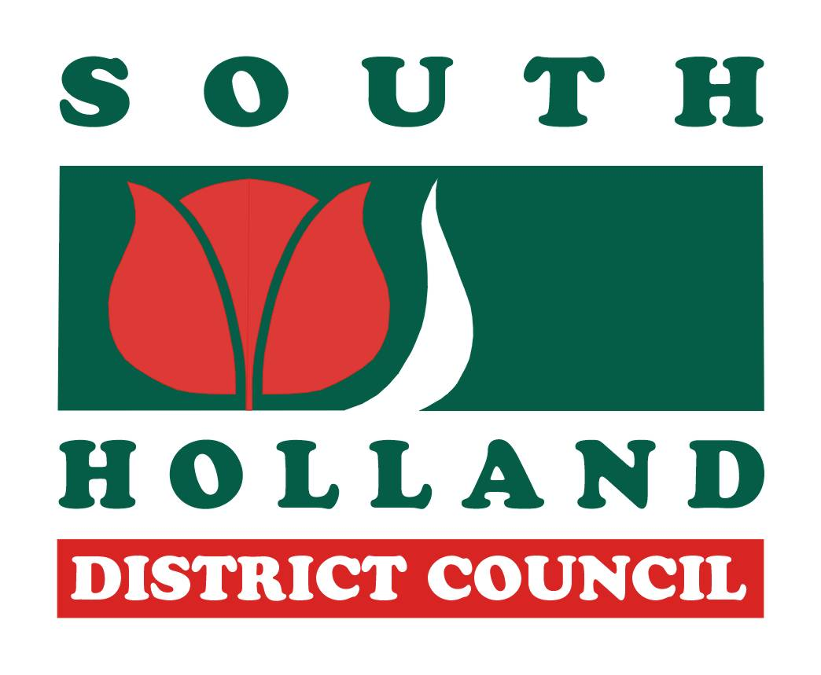

South Holland District Council
Property Services, Council Offices, Priory Road, Spalding,
Lincolnshire, PE11 2XE
Tel: (01775) 761161

The first thing you should ask yourself is

‘Do I really need to fill the dyke in question?’

Remember that many years ago the dykes were dug by hand. Many people laboured long and hard on the drainage of the Fens, a naturally wet, low lying area prone to flooding. Dykes were created for a reason – Land Drainage!

Dykes, unlike a pipe, have the capacity to hold a lot of water and in the event of a flood would drain the land much more effectively than a pipe.

Dykes also play a part in nature conservation, providing habitats for many plants and animals, such as the watervole. It is advised that you carry out a watervole survey before you think about filling a dyke.

It is widely accepted by the scientific community and politicians that global warming leading to rising sea levels is a real threat. When you are considering filling a dyke you should be aware of this.

The Government has asked all Drainage Authorities to publish a policy statement including an assessment of the risk of flooding in their area, and what plans they have to reduce that risk.

The Environment Agency is in general opposed to the culverting of watercourses, because of the adverse ecological, flood defence and other effects that are likely to arise.

Do you still wish to fill that dyke?

If yes, read on…

What you must do

Consult…
- your local authority - (The Public Health Act)
- your local drainage authority - (The Land Drainage Act)
- any adjacent owners ( your neighbours!)

It is important to remember that:
- you must make an application to your local authority and contact the relevant Internal Drainage Board.
- your application contains details (drawings) of how you intend to fill the dyke.

The local authority will

- acknowledge your application
- refer details to the Environment Agency, the local drainage board and, if it adjoins the road, the highway authority
- give you a decision within six weeks

PLEASE NOTE : Any consent given does not entitle the applicant to interfere with any other persons property, impede the flow in the water course, damage or interfere with any cables, wires or pipes which may be affected by the works.

The Application Process

I want to fill a dyke /drain

Contact
and/or
Local Drainage Board
Local Authority

Application Form

Application Form

Prepare drawings/details of your intentions

Submit Details

Await Response

If approved - carry out the works in strict accordance with consent

Details Required for Application

- Completed application form
- Location plan - Scale 1:2500
- Block plan/ site plan - Scale 1:500
- Cross section clearly showing details of fill
- Written specification

EXAMPLES OF WHAT SHOULD BE INCLUDED

A. TYPICAL CROSS SECTION
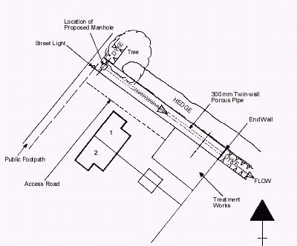
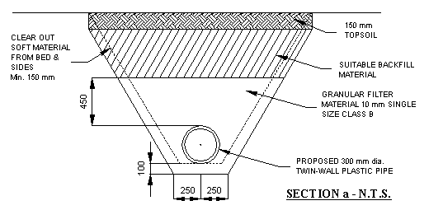

B. TYPICAL PLAN: LOCATION / SITE

Note: Manholes may be required for access

PLEASE NOTE : Your application will not be considered if your plans are not clear and well presented.

